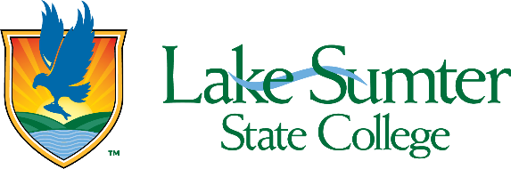
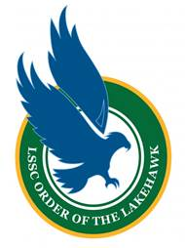

Order of the Lakehawk
Faculty/Staff Recommendation
The Order of the Lakehawk is the most prestigious and significant honor that a student may receive at Lake-Sumter State College. This honor recognizes outstanding academic achievement, dedicated college involvement, and significant community service. Membership in the Order recognizes the very best of our student body and an enduring connection to Lake-Sumter State College.

You have been asked to provide a written recommendation for a student to be considered for the Order of the Lakehawk.

Your recommendation of this student should address the following items:
- What is your role at LSSC?
- How long and in what capacity have you known the student nominee?
- Please describe how this student has demonstrated leadership and service to the college and/or our local community while enrolled at LSSC.
- Please describe how this student “stands out” from their peers. Why is this student deserving of membership in the Order of the Lakehawk?

Your recommendation should include your name, title, and LSSC email address.

Please provide your recommendation as a PDF to the student or submit it directly via email to Carolyn Scott, Dean of Students, at scottc@lssc.edu.

