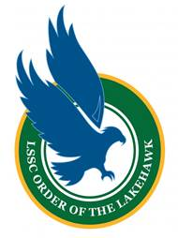
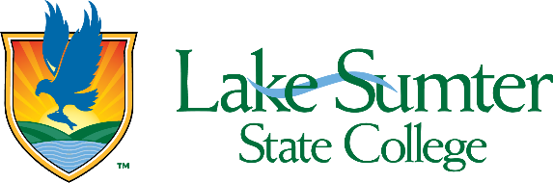

Order of the Lakehawk Selection Process
The Order of the Lakehawk is the most prestigious and significant honor that a student may receive at Lake-Sumter State College. This honor recognizes outstanding academic achievement, dedicated college involvement, and significant community service. Membership in the Order recognizes the very best of our student body and an enduring connection to Lake-Sumter State College.

The Order of the Lakehawk is reserved for up five (5) total summer and fall graduates and five (5) total spring graduates from all degree and certificate programs. Inductees will be honored at the fall or spring Commencement ceremonies.

Eligibility Criteria
- Eligible to participate in the upcoming Commencement (graduation application submitted)
- A minimum LSSC GPA 3.0 at the time of application
- Be in good conduct and financial standing at the time of application and remain in good standing through to Commencement
- Demonstrated strong leadership and/or service to the College and our local community while enrolled at LSSC

Application
To submit your application, email the following information to Dean of Students, Carolyn Scott at scottc@lssc.edu, no later than 11:59 PM on October 13, 2025.
- Nomination questionnaire
- Two recommendation letters from LSSC faculty or staff
- A recent resume

Selection Process
- Students who submit a completed application will be invited to participate in a brief online (recorded) interview with a member of the selection committee.
- The Selection Committee will review applications and interviews and make recommendations to the Vice President of Enrollment & Student Affairs and the College President.
- Selected students will be announced at the Commencement Ceremony.

