
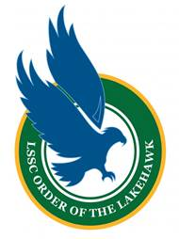
Fall

Order of the Lakehawk
Student Application Form
Please provide the following information about yourself
- Full Name
- X-ID
- Preferred Phone Number
- Lakehawk Email Address
- Degree/Program you are completing

Questionnaire
Please complete the following questions.

Did you apply to graduate for Fall 2025?

Selected students will be honored at the Commencement Ceremony. Which ceremony (Leesburg or South Lake, and ceremony time) do you plan to attend?

Please provide a summary of all the LSSC-based clubs or organizations that you have been involved with while enrolled at LSSC and indicate the length of your involvement.

Please provide a summary of any honors, awards, or achievements that you have received while enrolled at LSSC.

Please provide a summary of the community-based organizations or activities that you have been involved with while attending LSSC and indicate the length of your involvement.

Please describe how LSSC has impacted you, and/or how earning your degree or certificate will impact your life.

Is there any other information that you would like the selection committee to know about your experience at LSSC?

